Normalization on IQ and Parent Income. (How many centroids are there if both IQ and Parent Income are normalized?) : 5

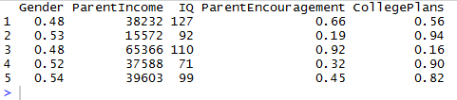



IQ is normalized. (How many centroids are there if IQ is normalized but Parent Income is not normalized?) 4

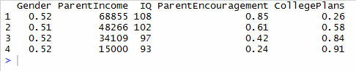



Parent Income is normalized. (How many centroids are there if IQ is not normalized but Parent Income is normalized?) 3

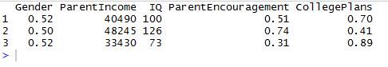



No Normalization. (How many centroids are there if neither IQ nor Parent Income are normalized?) 4

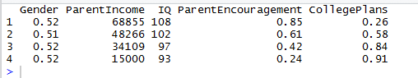



Readings with 1 cluster

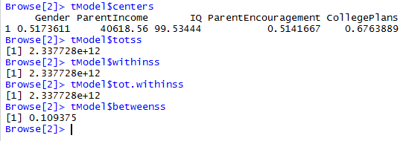

Reading with 2 clusters.

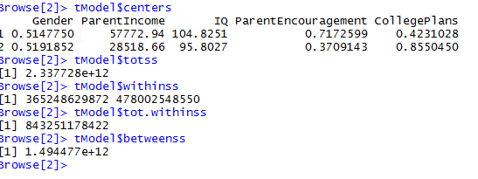

Reading with 3 clusters.

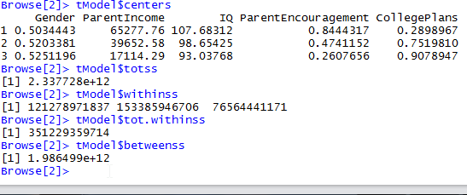

Reading with 4 clusters.

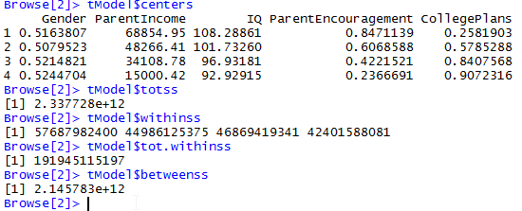

Reading with 5 clusters.

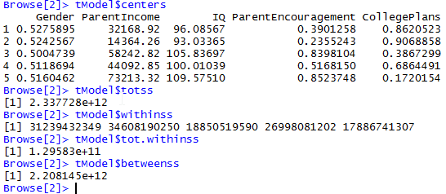

Reading with 6 clusters.

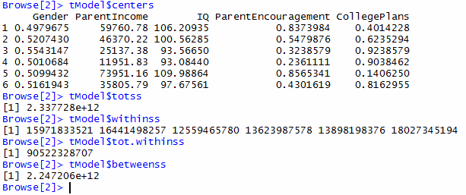

Reading with 7 clusters.

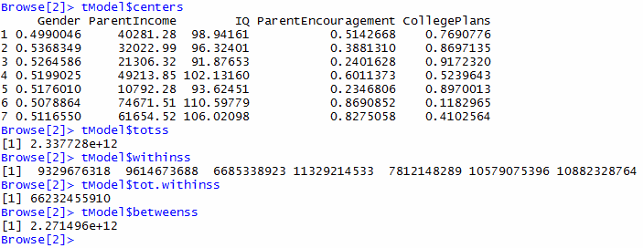

Reading with 8 clusters.

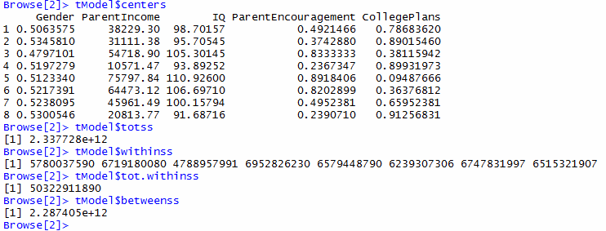

Reading with 9 clusters.

